USE CASES
for
CaBIG TM Adverse Event Reporting System (caAERS)
Version 2.0

Package Level Use Cases for
Capturing and Reporting of Adverse Events
(Modules 1-4)

Package 1: AE Data Capture
Package 2: Interface to Local Clinical Trial Databases
Package 3: Mapping to Vocabularies and Coding Systems
Package 4: Report Generation and Submission to
External Agencies

TABLE OF CONTENTS

Document Control 6
Use Case Introduction 7
Actors and Roles 8
Treating Physician 8
Principle Investigator 9
Study Coordinator 9
Study Administrator 9
System Administrator 9
Study Participant 9
ASSUMPTIONS AND DEPENDENCIES COVERING ALL USE CASES 11
PACKAGE 1 : AE DATA CAPTURE 13
Module 1 Use Cases - AE Data Capture 14
1.1 Create Protocol for AE Data Entry 14
Brief Description 14
Primary Actor 14
Secondary Actors 14
Preconditions 14
Basic Flow of Events 14
1.2 Create and Link Study Participant to a Protocol 17
Description 17
Post Condition 18
Alternate Course 1.2.4 Possible Duplicate Study Participant Found 18
Data 18
Notes 20
1.3 Link Existing Study Participant to an Existing Protocol 20
Description 20
Actor 20
Pre-Conditions 20
Basic Course 20
Post Condition 21
Alternate Course 1.3.4 Possible Duplicate Study Participant-Protocol Link Found 21
Data 21
Notes 21
1.4 Protocol Abstraction – Sponsors, Committees and Organizations 23
Basic Course 23
Post Conditions 24
Alternate Course 1.4.1 Edit Information 24
Alternate Course 1.4.2 Delete an Entity 24
Alternate Course 1.4.3 Enter an Event (e.g. actions, decisions from associated entities that may affect recording and reporting of AEs) 24
Data Item 25
AERS Class (Types) 25
Entity Event 25
1.5 Create AE 26
Brief Description 26
Primary Actor 26
Secondary Actors 26
Preconditions 26
1.6 AE Data Collection 28
Data Item 29
Type 29
Notes/Validation Rules 29
AERS Class 29
Notes 30
1.7 Search AE Entry 31
Actors 33
Data Item 34
Type 34
Notes/Validation Rules 34
AERS Class 34
1.9 Configure Institution AE Notification Triggers 34
Type 36
Validation 36
AERS Class 36
Type 38
Validation 38
AERS Class 38
1.11 Configure Protocol Level AE Notification Triggers 38
Pre-Conditions 39
Type 40
Validation 40
AERS Class 40
1.12 Configure Messages, Timing and Escalation Rules for Notifications 40
Actors 41
PACKAGE 2: DATA EXCHANGE WITH LOCAL CLINICAL TRIALS DATABASES 43
2.1 Import of Related Patient and Protocol Data Pre-Existing in a CT Database System 44
Basic Course-Structure File Set 44
Basic Course-Application Programming Interface 44
Use Case dependency 45
Priority Assignment: TBD 45
2.2 Export of AE Information into Local CTMS Databases for Future Aggregation and Analysis 46
Basic Course-Structure File Set 46
Basic Course-Application Programming Interface 46
Use Case dependency 47
Priority Assignment: TBD 47
PACKAGE 3 : MAPPING TO VOCABULARIES AND CODING SYSTEMS 48
MODULE 3 USE CASES: MAPPING TO VOCABULARIES AND CODING SYSTEMS 49
3.1 Mapping to Vocabularies and Coding Systems 49
Basic Course-Report Generation 49
Use Case dependency 50
Type 50
Validation 50
Priority Assignment: TBD 50
PACKAGE 4 : REPORT GENERATION AND SUBMISSION TO EXTERNAL AGENCIES 51
Module 4 Use Cases – Routing to External Agencies 52
4.1 Create Report Formats 52
1 – critical to prototype; 2 – future development; 3 – out of grant scope 53
4.2 Generate Report Form 54
4.3 Submit Report 56
1 – critical to prototype; 2 – future development; 3 – out of grant scope 57
13.0 General Use Cases 58
13.1 Login 58
Data Item 59
13.2 Change Password 60
Potential Use Cases 62

Document Control

Release

Version | Date Released | Change Notice | Pages Affected | Author | Remarks
1.0 | 2/4/2005 |  |  | CSong | Initial draft surveys for internal release
1.1 | 3/4/2005 |  |  | CSong | Initial draft use cases for internal and AE SIG review
1.2 | 3/7/2005 |  |  | CSong | Updates per internal review; initial draft Package 4
1.3 | 3/9/2005 |  |  | CSong/  CStahl | Updated Package 4 data elements; updated flow and data elements for Use Cases 1.5, 1.6 as per AE SIG input
1.4 | 3/17/2005 |  |  | CSong/  CStahl | Updated Use Cases 1.5, 1.6 as per SIG input; flushed out 1.9-1.11 for triggers
1.5 | 3/23/2005 |  |  | CSong | Updated Use Cases 1.9-1.11 as per internal review and feedback from AE SIG
1.6 | 4/20/2005 |  |  | CSong | Updated Use Cases 1.9-1.11 as per feedback SIG and F2F
1.7 | 5/25/2005 |  |  | CSong | Updated Use Cases 1.6-1.6, 1.9-1.11 per AE SIG WG validation exercises
1.8 | 5/31/2005 |  |  | CSong | Initial draft surveys and use cases for Module 2 for internal release and AE SIG review
1.9 | 6/1/2005 |  |  | CStahl/  CSong | Initial draft surveys and use cases for Module 3 for internal release and AE SIG review
1.10 | 6/7/2005 |  |  | CSong | Initial draft surveys and use cases for Module 4 for internal release and AE SIG review
1.11 | 6/13/2005 |  |  | CSong | Updated Use Cases 4.1-4.3 per AE SIG review
1.12 | 6/22/2005 |  |  | CSong | Updated Use Cases 1.1-1.13 per AE SIG validation and internal review
2.0 | 1/10/07 |  |  | J Osborne | Rewritten based on feedback from teleconferences and F2F meeting

Use Case Introduction

This document presents design-level use-cases, organized by packages, which corresponds to the 12 modules under development for Adverse Event Reporting in the CTMS Workspace. This document defines a use case as a sequence of actions that an actor (usually a person, but perhaps an external entity, such as another system) performs within a system to achieve a particular goal. A use case describes one or more courses through a user operation. A new use case is created if the post condition is different. The standard course is always present; an alternate course is optional and has the same post condition or may connect one use case to another case. The result of use case modeling is that all required system functionality is described. In this modeling technique, a use case can satisfy one or more functional requirements; a functional requirement may be satisfied by one or more use cases.

Use Case Numbering
Example use case number: 1.0.4a
1.0.4a – Represents a category of the use case.
1.0.4a – Represents a sequential number assigned to a use case in a category
1.0.4a – Represents an alternate course in a use case and corresponds to the basic course step from which it branches.
1.0.4a – Represents an attached document (e.g. an example data entry screen)

Use Case Legend
* next to a data item means it is a required field
^ at the end of a basic course step means there is an alternate course

The Description Section of a Use Case
This is the function of the use case.

The Actor Section of a Use Case
This is to identify all persons or systems that execute a step within a use case.

The Pre-Conditions Section of a Use Case
What has occurred before a use case can be invoked.

The Basic Course Section of a Use Case
The step-by-step most common actions that will result in the desired post conditions.

The Post Condition Section of a Use Case
The outcome of a use case.

The Alternate Course Section of a Use Case
Usually occurs if a decision or possible ‘other’ step from the basic course is needed but comes back to the same post condition of the use case or exits out of the function.

The Data Item Section of a Use Case
Detail on each data item used during a use case.

The Coding System Section of a Use Case
If there is a data item with a set list of possible values a code table will be present.

The Notes Section of a Use Case
These are general statements about the function of a use case to aid development.

The Risks Section of a Use Case
Identified risks to the use case function.

The Priority Section of a Use Case
This is an aid to prioritize use case development.

The Use Case Dependency Section of a Use Case
Lists all the use cases that are referenced within a use case to highlight relationships and possible risks if a use case is modified.

References
This Use Case document is a work in progress. It reflects information obtained from initial interviews with AE domain experts at City of Hope National Medical Center, the Chao Cancer Center at the University of California Irvine Medical Center, the Mayo Clinic College of Medicine, University of Pittsburgh Cancer Institute, Wake Forest Comprehensive Cancer Center, Duke University Medical Center, Northwestern University and Dartmouth Medical Center as well as experts from external reporting agencies, including CTEP, DCP and the FDA. Feedback obtained during AE SIG teleconferences and from the exercise conducted at the CTMS Face-to-Face Meeting will also be incorporated.

Actors and Roles

Further discussion is needed to describe all the actors and roles that are expected in caAERs. A preliminary list of actors is presented here. Roles are not yet included.

Treating Physician
The physician is the medical doctor who treats clinical trial participants.

Principle Investigator
The Principal Investigator of a clinical trial.

Study Coordinator
The person responsible for setting up the study in the system, creating the protocols, defining adverse events in the system and generally setting the parameters of a study.

Study Administrator
The person responsible for entering in adverse events as they occur

System Administrator
This person is responsible for maintaining the caAERs software.

Study Participant
A patient qualified and enrolled in a study. Not necessarily assigned to a protocol yet.

High Level caAERS Diagram:
The diagram shown on the next page provides a graphic representation of the 12 modules comprising the Adverse Event Reporting System.
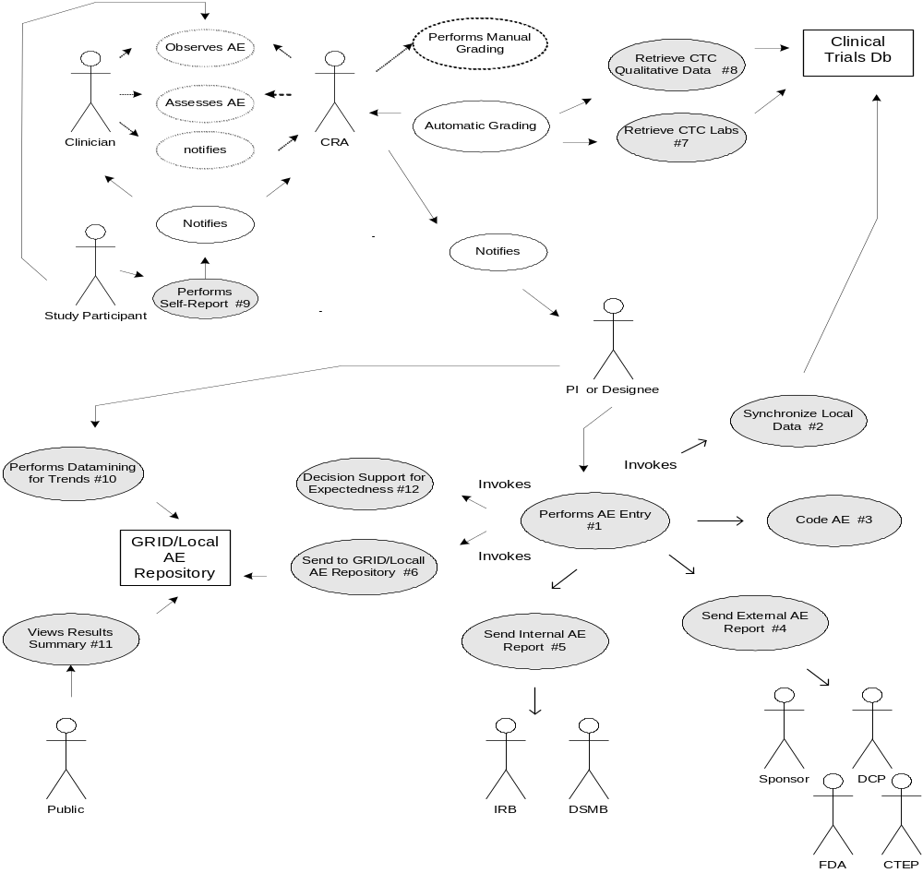

ASSUMPTIONS AND DEPENDENCIES COVERING ALL USE CASES
General Assumptions
1. The scope of this SOW will be limited to collecting business requirements for Modules 1 through 4 and preparation of artifacts to document those requirements. Design documents for the initial implementation of these modules will be created in a separate SOW, but will be based on the requirements established herein.
2. For greater efficiency and to allow a broader view of the community involved, modules 1 and 4 will be addressed together. Information collected during this period that pertains to modules 2 and 3 will be recorded and saved but may require revisiting when we begin documenting those modules.

Project Management Assumptions:
3. An Issues Log will be maintained throughout the interview and specifications development periods. These will be posted for discussion and each must be resolved, confirmed as “not really an issue”, or delayed for resolution at a later time based on circumstances.
4. Our objective is full consensus of the requirements. However, due to the large number of participants with vastly different levels of technological proficiency and implemented systems (both automated and manual), it may not be possible. Therefore, a compromise may need to be reached and will be required prior to development of a solution following this phase of the project.
5. In the event that a consensus cannot be reached, NCI will be the final authority in how implementation of the caAERS will proceed.
6. COH’s plan for management of this project will be submitted as indicated in the attached project plan. It is anticipated that any required changes or clarifications be requested within 14 days of submission of that milestone so that the plan can be accepted without impacting the remainder of the project phase. All subsequent phases of the AE Reporting System project will be managed according to that plan.
7. Any modifications to the scope of work will be handled through a change control process and will be agreed upon by both NCI and City of Hope. Due to the nature of the iterative development process, most modifications can be addressed during subsequent phases.

Requirements Gathering Assumptions:
8. An 8-week window has been established in which to conduct the initial interviews. This should be adequate to provide a baseline from which to start the development of specifications. Subsequent/follow-up interviews can fill in any gaps or misunderstandings identified, and allow for refinement of specifications throughout this phase. An iterative process for development and review of specifications will depend on the participation of all members of the SIG.
9. Adopter Sites to be interviewed will fall into three categories:
a. Institutions with a completely manual process of reporting AEs
b. Institutions with fully automated/integrated AE capture and reporting systems
c. Institutions with hybrid systems
10. The resources and time frame reflected in the project plan assumes a maximum of ten (10) adopter sites will be interviewed and those selected will represent all three categories
11. It is not necessary that all of the interviews be conducted on-site. It is, however, required that each site make available the appropriate domain experts for a thorough understanding of AE related process and applications at that site.

12. All domain experts will understand the scope of the modules for which we are gathering requirements and will provide information accordingly. Interviewing techniques will include personal interviews (in person or by phone), conference calls, surveys, and requests for written documentation and responses.

Requirements Documentation Assumptions:
13. The requirements artifacts identified in the project plan are adequate to document the requirements for all four modules. No additional formats and/or artifact types will be required. The documents will focus on requirements of a new system, NOT on how that new system will be implemented.
14. Feedback on artifacts will not wait on completion of all documents, but will be provided instead as drafts are made available. The final review period is intended for fine tuning and brainstorming of needs and wishlist items that might have been missed.
15. A responsible party will grade toxicities prior to entry into the system during this portion of the caAERS system development. Automation of grading is addressed in later modules.

PACKAGE 1 : AE DATA CAPTURE
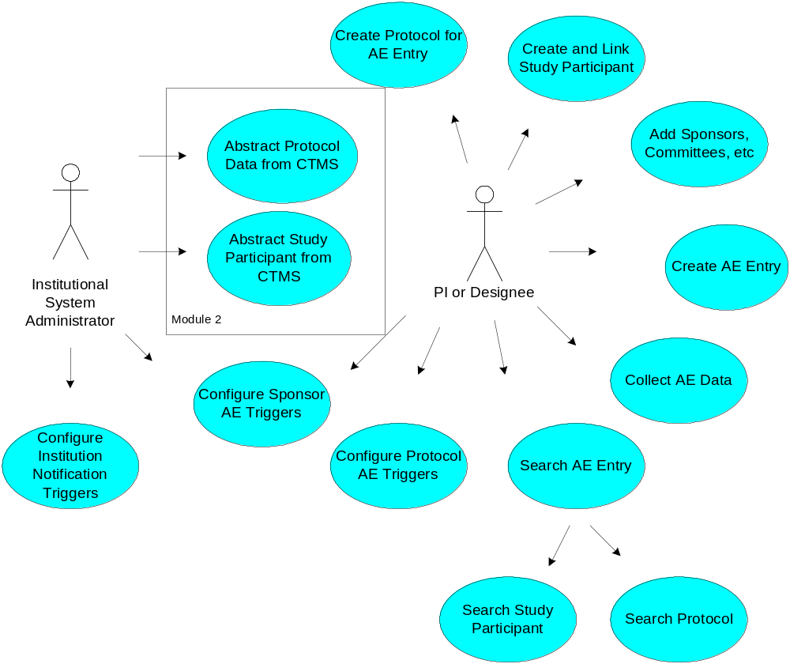

Module 1 Use Cases - AE Data Capture

1.1 Create Protocol for AE Data Entry

Brief Description
Create a Study Participant from an existing patient information and links the new Study Participant to an existing protocol for the abstraction of protocol AE data.
(Note: Module 2 Use Case 2.2 represents the caAERS function for abstracting protocol linked Study Participant data from the CaBIG BRIDG module or from an existing CTMS)

Primary Actor
Study Administrator

Secondary Actors
Systems Administrator

Preconditions
- The user is logged in to the system with a user account that has role authority for this use case.
- The user has Study Participant information to register and link to an existing protocol. The Study Participant is qualified to be enrolled in the study. CaAERS does not manage patient eligibility or accessioning workflow.
- Minimum protocol data for the abstraction of AE data exists (Use Case 1.1). User may have searched for this protocol (Use Case1.11)
- (Optional) The actor may utilize the Search Study Participant function to verify the Study Participant has not already been created in the system.
- (Optional) The actor may also rely on the duplicate check function identified in the basic flow of events below.

Basic Flow of Events
- The Actor selects Create Study Participant.
  - The system displays a page that allows the actor to register the Study Participant. The following minimum patient information is requested (see the table of Data in this section)
- Actor clicks the ‘Create and Link Study Participant’ button
- The system checks for duplicate Study Participant. System does not find duplicate. (^Alternate course 1.2.4 Possible Duplicate Study Participant Found)
- The system assigns a unique system identifier indicating that the Study Participant has been successfully created and linked to the selected protocol.
- The system displays a create date as confirmation to the actor of successfully creating a Study Participant and linking to an existing protocol.

Post Condition
- AE required Study Participant data is stored in the system and linked to an existing protocol.
- Unique System ID assigned.
- The actor is viewing a confirmation of Study Participant creation.

Alternate Course 1.2.4 Possible Duplicate Study Participant Found
  - The system checks for a complete match on all of the following data elements
    - First Name
    - M.I.
    - Last Name
    - Gender
    - DOB.
  - If all match then alert the actor of a possible duplicate Study Participant. If any of the three data elements don’t match then no alert is generated.
  - The actor views a page with the possible duplicate participant data.
  - The actor may choose the following buttons:
  - ‘Continue with Study Participant Creation’ button and continue Basic Course of this Use Case at step 5. First Name, Last Name, Gender and DOB must be changed or a duplicate warning with occur again OR
  - ‘Cancel’ to the main menu page without creating the new Study Participant.

Data
Data Item | Notes/Validation Rule | AERS Class
Institutional Patient Identifier | Support multi-institutional patient identifiers | TreatingInstitution
Institution Name | Coded element, Required | TreatingInstitution
Study Participant Name | (Required or Optional based on local site configuration) | StudyParticipant
Prefix | Coded element, (Required or Optional based on local site configuration)
First Name | (Required or Optional based on local site configuration)
Middle Initial | (Required or Optional based on local site configuration)
Last Name | (Required or Optional based on local site configuration)
Suffix | Coded element, (Required or Optional based on local site configuration)
Maiden Name | Alpha only, Not Required
Current Address | (Required or Optional based on local site configuration) | StudyParticipant
Street Address | Not Required
City | Not Required, Coded
State | Not Required, Coded
Zip Code | Not Required, Coded
Home Phone | Not Required | StudyParticipant
Mobile Phone | Not Required | StudyParticipant
Work Phone | Not Required | StudyParticipant
Date of Birth | Mm/dd/yyyy, forced format or calendar, Required | StudyParticipant
Gender | Coded, Required | StudyParticipant
Race | Coded, Not required | StudyParticipant
Ethnicity | Coded element, Not required | StudyParticipant
Birth City | Alpha only (Required or Optional based on local site configuration) | StudyParticipant
Birth State | Alpha only, (Required or Optional based on local site configuration) | StudyParticipant
Birth Country | Coded, (Required or Optional based on local site configuration) | StudyParticipant
caAERS TM Study Participant Unique ID | System assigned | StudyParticipant
caAERS TM Study Participant Create date | System created date | StudyParticipant
caAERS TM Study Participant Edit date | System created date | StudyParticipant
User ID | System UserID –to audit user create and edit actions

Notes
- A protocol may exist in the system without a Study Participant. A Study Participant may not exist in the system without being linked to at least one existing protocol.
- Study Participant data either never changes or changes infrequently.
- The actor can exit out of the function at any time.
- Data are not overwritten. A new record is created. Only the most recent update is displayed
- An audit trail is provided
- May need use case to merge/reconcile/link institutional patient records if they are mistakenly entered as duplicates.

Unresolved
- How should ‘Institution’ be used – is this a drop-down field? Is it filled in automatically? If so, where do the value(s)come from?
- What codelist/standards should be used for Gender, Race, Ethnicity field. Check for CDE’s with VCDE.

1.2 Create and Link Study Participant to a Protocol

Description
This use case identifies the process whereby actors with the appropriate role authority will create a Study Participant and link to existing protocol for the abstraction of protocol AE data. (Note: Module 2 Use Case 2.2 represents the caAERS function for abstracting protocol linked Study Participant data from the CaBIG BRIDG module or from an existing CTMS) A patient must be entered in the system and linked to a protocol before he or she can be a Study Participant. A Study Participant is a patient that has qualified for a study and enrolled onto the study. A Study Participant is receiving the study treatment or intervention. Currently, it is assumed that the Study Participant is eligible for the study and has been appropriately accessioned to the study. CaAERS does not manage patient eligibility or accessioning workflow. For ease of reading, the term Study Participant will be used to signifiy a patient enrolled onto a study in this document.

Actor

caAERS System Administrator or any other designated user of caAERS ^{sm} with appropriate role authority for this task.

Pre-Conditions

The actor has successfully logged into the system and has Study Participant information to register and link to an existing protocol. Minimum protocol data for the abstraction of AE data exists (Use Case 1.1). The actor may (optionally) utilize the Search Study Participant function to verify the Study Participant has not already been created in the system. The actor may also rely on the duplicate check function identified in the basic course below. The actor has searched for a protocol (Use Case 1.11).

Basic Course
- The actor selects Create Study Participant.
- The system displays a page that allows the actor to register the Study Participant. The following minimum patient information is requested
- Institutional Patient Identifier
- Institution *

- Study Participant Name
- Prefix
- First name*.
- Middle Initial*
- Last name*
- Suffix
- Maiden Name

- Date of Birth*
- Gender*
- Race*
- Ethnicity*
- Street Address
- City
- State
- Zip Code
- Home Phone
- Mobile Phone

(*means required fields)

- Actor clicks the ‘Create and Link Study Participant’ button
- The system checks for duplicate Study Participant. System does not find duplicate. (^Alternate course 1.2.4 Possible Duplicate Study Participant Found)
- The system assigns a unique system identifier indicating that the Study Participant has been successfully created and linked to the selected protocol.
- The system displays a create date as confirmation to the actor of successfully creating a Study Participant and linking to an existing protocol.

Post Condition

AE required Study Participant data is stored in the system and linked to an existing protocol. Unique System ID assigned. The actor is viewing a confirmation of Study Participant creation.

Alternate Course 1.2.4 Possible Duplicate Study Participant Found
1. The system checks for a complete match on data elements – First Name, M.I.. Last Name, Gender, and DOB. If all match then alert the actor of a possible duplicate Study Participant. If any of the three data elements don’t match then no alert is generated.
- The actor views a page with the possible duplicate participant data.
- The actor may choose the following buttons:
‘Continue with Study Participant Creation’ button and continue Basic Course of this Use Case at step 5. First Name, Last Name, Gender and DOB must be changed or a duplicate warning with occur again
OR
‘Cancel’ to the main menu page without creating the new Study Participant.

Data
Data Item | Notes/Validation Rule | AERS Class
Institutional Patient Identifier | Should support multiple institutional identifiers | TreatingInstitution
Institution Name | Coded element, Required | TreatingInstitution
Study Participant Name |  | StudyParticipant
Prefix | Coded element
First Name | Required
Middle Initial | Not Required
Last Name | Required
Suffix | Coded element
Maiden Name | Alpha only, Not Required
Current Address |  | StudyParticipant
Street Address | Not Required
City | Not Required, Coded
State | Not Required, Coded
Zip Code | Not Required, Coded
Home Phone | Not Required | StudyParticipant
Mobile Phone | Not Required | StudyParticipant
Work Phone | Not Required | StudyParticipant
Date of Birth | Mm/dd/yyyy, forced format or calendar, Required | StudyParticipant
Gender | Coded, Required | StudyParticipant
Race | Coded, Not required | StudyParticipant
Ethnicity | Coded element, Not required | StudyParticipant
Birth City | Alpha only, Not Required | StudyParticipant
Birth State | Alpha only, Note Required | StudyParticipant
Birth Country | Coded, Not Required | StudyParticipant
caAERS ^{sm} Study Participant Unique ID | System assigned | StudyParticipant
caAERS ^{sm} Study Participant Create date | System created date | StudyParticipant
caAERS ^{sm} Study Participant Edit date | System created date | StudyParticipant
User ID | System UserID –to audit user create and edit actions

Notes
- A protocol may exist in the system without a Study Participant. A Study Participant may not exist in the system without being linked
to at least one existing protocol.
- Study Participant data either never changes or changes infrequently.
- The actor can exit out of the function at any time.
- Data are not overwritten. A new record is created. Only the most recent update is displayed. An audit trail is provided
- May need use case to merge/reconcile/link institutional patient records if they are mistakenly entered as duplicates.
- Allow configuration at site to set which fields are required and which are optional such as patient contact info, birth city, state, etc…

1.3 Link Existing Study Participant to an Existing Protocol

Description
This use case identifies the process whereby actors with the appropriate role authority will link an existing Study Participant to existing protocol for the abstraction of protocol AE data. (Note: Module 2 Use Case 2.2 represents the caAERS function for importing protocol linked Study Participant data from the the CaBIG BRIDG module or from an existing CTMS.) A patient must be entered in the system and linked to a protocol before he or she can be a Study Participant. A Study Participant is a patient that has qualified for a study and enrolled onto the study. A Study Participant is receiving the study treatment or intervention. Currently, it is assumed that the Study Participant is eligible for the study and has been appropriately accessioned to the study. CaAERS will not manage patient eligibility or accessioning workflow. For ease of reading, the term Study Participant will be used to signify a patient that has been enrolled onto a study in this document.

Actor

caAERS System Administrator or any other designated user of caAERS ^{sm} with appropriate role authority for this task.

Pre-Conditions

The actor has successfully logged into the system. Study Participant information exists (and is linked to at least one existing protocol) The target protocol to link a Study Participant already exists (Use Case 1.1).

Basic Course
Option 1:

1. The actor has searched for the protocol (Use Case 1.13) and has selected the Search for Study Participant button.
2. The actor searches for an existing Study Participant (Use Case 1.14)
- After an existing Study Participant has been selected, the actor selects ‘Link to Protocol’ or may cancel the action by selecting the ‘Cancel’ button.
Option 2:

1. The actor has searched for an existing Study Participant (Use Case 1.14) and has selected the Search for Protocol button.
2. The actor searches for an existing protocol (Use Case 1.13)
3. After an existing protocol has been selected, the actor selects ‘Link to Study Participant’ or may cancel the action by selecting the ‘Cancel’ button.
- The actor is prompted to confirm the linking of the selected Study Participant to the protocol.
- The system checks for an existing Study Participant-Protocol link. System does not find duplicate (^Alternate course 1.3.4 Duplicate Study Participant-Protocol Link Found)
- System displays confirmation that selected Study Participant has been linked to the selected protocol.

Post Condition

Existing Study Participant is linked to one or more existing protocols. The actor is viewing a confirmation of Study Participant linking to an existing protocol.

Alternate Course 1.3.4 Possible Duplicate Study Participant-Protocol Link Found
1. The system checks for an existing linkage of the Study Participant and Protocol. If an existing linkage is found, an alert is generated. If no linkage is found, no alert is generated.
- The actor views a page with information on the duplicate Study Participant-protocol link.
- The actor may choose the following buttons:
‘Continue with Study Participant Protocol Link’ button and continue Basic Course of this Use Case at step 1 of either Option. The Study Participant or protocol selected must be updated or a duplicate warning with occur again.
OR
‘Cancel’ to the main menu page without creating the new Study Participant-Protocol link

Data
Data Element | Notes/Validation | AERS Class
StudyParticipantID | Should support multiple institutional identifiers | StudyParticipant
Protocol ID |  | Protocol
caAERS ^{sm} Study Participant-Protocol Link ID | System assigned
caAERS ^{sm} Study Participant-Protocol Link Create date | System created date
caAERS ^{sm} Study Participant-Protocol Link Edit date | System created date
User ID | System UserID –to audit user create and edit actions

Notes
- Allow configuration at site to set fields are required and which are optional such as patient contact info, birth city, state, etc…
- May need use case to merge/reconcile/link institutional patient records if they are mistakenly entered as duplicates.

1.4 Protocol Abstraction – Sponsors, Committees and Organizations

Description
This use case links additional sponsors and committees and organizations that are important to the management of the protocol as they relate to the recording and reporting of adverse events. The actor will be able to enter/update information about the entities (sponsors, committees, and organizations) . The basic course of action is to link an entity to the protocol by adding the entity to a collection associated with the protocol. The alternate courses are: edit information, delete an entity, or enter an event.

Actor
caAERS System Administrator or any other designated user of caAERS ^{sm} with appropriate role authority for this task.

Pre-Conditions
The protocol exists and the system administrator has entered all appropriate institutional values for the coded elements: Sponsor, Committees and Organizations as per the System Administrator Use Case package (TBD). The actor has successfully logged into the system.

Basic Course
1. The actor has navigated to the protocol abstraction screen – Sponsors, Committees, and Organizations.
2. The actor has searched for the interested protocol (Use Case 1.13).
3. The selects one of these OPTIONS:
a. The actor clicks on the add button next to a ‘other sponsor’ category label ( ^Alternate courses 1.4.1, 1.4.2, 1.4.3, 1.4.4)
b. The actor clicks on the add button next to the ‘other committees’ category label (^Alternate courses 1.4.1, 1.4.2, 1.4.3, 1.4.4)
c. The actor clicks on the add button next to the ‘other organization’ category label.( ^Alternate courses 1.4.1, 1.4.2, 1.4.3, 1.4.4)
4. The system displays the appropriate data information screen.
5. The actor:
a. chooses a sponsor, committee or organization from a pick-list of items or creates a new entity to associate to the protocol
b. enters the sponsor, committee or organization protocol ID
c. enters the sponsor, committee or organization protocol version
d. enter the sponsor, committee or organization protocol version date
e. enters the required review date
e. completes contact person information (optional)
f. clicks on save - Continue to step 7.
6. The system adds the sponsor, committee or organization under the ‘protocol conditions’ column and displays the code-value and rule.
7. The system saves the information and displays the protocol abstraction screen – Sponsors, Committees, and Organizations again.
8. The actor clicks on the add button.
9. Repeat steps 4 – 7 until all applicable entities are added.
10. The actor may exit or continue with any of the alternate courses below.

Post Conditions
Additional sponsors, committees and/or organizations relevant to the management of the protocol related to recording and reporting of adverse events have been linked to the protocol.

Alternate Course 1.4.1 Edit Information
1. The actor clicks on the entity’s name (e.g SWOG under the additional sponsor category).
2. The system displays the entity information page with the most current data.
3. The actor changes the data and clicks the save button if all data validation rules have passed.
4. The system saves the information and displays the protocol abstraction page – Sponsors, Committees, and Organizations again. .
5. The actor may:
a. Check the changes by clicking on the entity’s name again and the information screen will display with the updated data.
b. Continue editing another entity
c. Continue with another function
d. Exit caAERS

Alternate Course 1.4.2 Delete an Entity
1. The actor clicks on the entity’s name (e.g. SWOG under the additional sponsor label).
2. The system displays the entity information page with the most current data.
3. The actor clicks the delete button.
4. The system displays a question to confirm – do you want to delete this (e.g. sponsor) for this protocol?”
5. The actor clicks:
a. Yes, the system detaches the entity from the protocol, no longer displays the information on the protocol abstraction screen.
b. No, the system returns the actor to main page.
6. The actor may:
a. Continue deleting another entity
b. Continue with another function
c. Exit caAERS

Alternate Course 1.4.3 Enter an Event (e.g. actions, decisions from associated entities that may affect recording and reporting of AEs)
1. The actor clicks on the event status associated with an entity.
2. The system displays the event page to select and enter data about actions and/or decisions configured for the entity. All data is editable except the Name & Protocol ID data elements are display only.
3. The actor add or edits the data about an action or decision and clicks the save button.
4. The system saves the information and displays the protocol abstraction page – Sponsors, Committees, and Organizations again.
5. The actor may:
a. Check the changes by clicking on the status again and the event page will display with the updated data.
b. Continue editing another event
c. Continue with another function
- Exit caAERS

Alternate Course 1.3.4 View Event History
1. The actor clicks on an event history button associated with an entity.
2. The system displays a page with a list of status and status date.
3. The actor may:
a. Click on the status date and view the event information
b. Continue with another function
c. Exit caAERS

Data Items
Data Item | AERS Class (Types)
Entity | Sponsor, Committee, Funding Agency, External Regulatory Agency, Multi-Center Consortium
Entity Name
Entity Protocol ID
Entity Protocol Version (not required, although best if requirement decision is configurable for a particular site)
Entity Protocol Version Date (not required, although best if requirement decision is configurable for a particular site)
EntityID (e.g. sponsor ID)
Required Review Date
Contact First Name, Last Name, Middle Initial
Contact Title
Contact Telephone
Contact Fax
Entity Event | Entity Event
Action (e.g. pick-list associated with entity)
Action Date
Action Contact: First Name, Last Name, Middle Initial
Action Narrative

1.5 Create AE

Brief Description
Create a new AE Entry for a given Study Participant linked to an existing protocol.

Primary Actor
Study Administrator, PI

Secondary Actors
Systems Administrator

Preconditions
1. The actor has successfully logged into the system.
2. The protocol has successfully been created.
3. The Study Participant has been created and linked to an existing protocol.

Basic Flow of Events
- The actor searches and selects a Study Participant (Use Case 1.14) on which to record an AE. If the Study Participant is linked to multiple protocols, the applicable protocol must also be selected
- The actor selects option to create a new AE Entry.
- The initial data screen is presented with protocol and Study Participant identified.
- Actor prompted to input the minimum data needed to create an AE :
- Keyword Search or Pick List items of CTC Categories and AE Terms or manual input of MedDRA code
- AE Detection Date (See notes and dictionary for definition)
- AE Grade
- Expectedness
- Attribution
- Hospitalization

- caAERSTM searches for possible duplicate of existing AEs (See Notes 3 below). No duplicate found OR
  - Alternate course 1.5.5 Possible Duplicate AE for Study Participant Found
  - Duplicate found based on Note #3
  - Notifies the actor of duplicate and displays the possible duplicate/s
  - Actor is prompted to ‘CONTINUE’ the create AE function - then continues with Flow of Events OR
  - or ‘CANCEL’ create AE function –then defaults to the main menu
- Actor selects ‘SAVE’ button.
- caAERSTM creates unique AE Entry ID and timestamp with User ID noted. Audit trail is available
- Actor is viewing a confirmation window and can choose to ‘EXIT’ (defaults to main menu. See Note 4 below) or ‘CONTINUE DATA COLLECTION’ (see Use Case 1.6).

Post Conditions
- Actor will have created an AE for a Study Participant linked to an existing Protocol.
- Configured triggers are invoked.
- Subsequent AE data collection may occur.
- The AE is in a Pending state.

Data Item
Data Item | Type | Notes/Validation Rules | AERS Class
AE Detection Date | Required for duplicate check, not required for minimal AE | Def: date recorded in source documentation or by pt. or family caregiver. | AdverseEvent
Stop Date | Optional |  | AdverseEvent
MedDRA Code | Required if AE category and term not provided. |  | AdverseEvent
Category | Required if MedDRA Code not provided. |  | AdverseEvent
Course | Not required for minimum AE. Optional for non-treatment trials. |  | AdverseEvent
Cycle | Not required for minimum AE. Optional for non-treatment trials. Should be varchar ex)week 1 |  | AdverseEvent
CTC Version | Requried if MedDRA Code not provided. | CTC v2.0/3.0 | AdverseEvent
Term | Requried if MedDRA Code not provided. |  | AdverseEvent
Grade | “Requiredness” dictated by configured institution, sponsor and protocol triggers |  | AdverseEvent
Other, Specify | “Requiredness” dictated by configured institution, sponsor and protocol triggers | (*NOTE: Other (Specify, ______) is an AE Term for a selected Category | Adverse Event
Expectedness | “Requiredness” dictated by configured institution, sponsor and protocol triggers | Timing and who of reporting dictated by configured institution, sponsor and protocol triggers | ProtocolTreatmentAdverseEventLink
Attribution | “Requiredness” dictated by configured institution, sponsor and protocol triggers | Timing of reporting dictated by configured institution, sponsor and protocol triggers | ProtocolTreatmentAdverseEventLink
Hospitalization | “Requiredness” dictated by configured institution, sponsor and protocol triggers | DCP or CTEP definitions may be utilized | ProtocolTreatmentAdverseEventLink
Treating Physician | Required
Primary sponsor protocol version | Required | User would enter protocol by name, matching protocols would be listed

Notes
- Pre-existing conditions system derived from previous AE records
- Dose Limiting toxicity derived protocol triggers; dose limiting management not covered in initial phase of caAERS
- Business rule for determining a duplicate AE: a) match on CTC AE Category and Term or MedDRA Code and if detection range is within 30 days of an existing AE for the Study Participant
- If the actor chooses to ‘EXIT’ on basic Course step 8 then caAERS will notify the user to complete the data collection within ?? time frame.
- The creation of an AE should be a staged process. First, the user is required to enter only the minimal data needed to create the AE. Only if the AE is elevated to an SAE should the user be required to enter larger set of data needed for expedited reporting. But we must be cognizant while working of this to make sure we collect enough information at each stage to support trigger/rules creation.
- What happens if an AE applies to two protocols? The answer: Enter the AE for both protocols. The caAERS s/w should create 2 records (if told to). The user would then be responsible for managing the two AEs.

Unresolved
How we can track dates for AE’s for non-standard trials, e.g., stem-cell transplant trial?

1.6 AE Data Collection

Description
This use case identifies the process whereby actors with the appropriate role authority can enter additional data on an existing AE for an existing Study Participant linked to a protocol. The “requiredness” of data elements is dynamically determined based on configured triggers and reporting needs.

Actors
Any user designated user of caAERS ^{sm} with appropriate role authority.

Pre-Conditions
The actor has logged into caAERS ^{sm} and has the appropriate role authority to access this function. An AE exists for an existing Study participant. The protocol has successfully been created. Notification triggers have been created. The Study Participant has been created and linked to an existing protocol.

Basic Course
- The actor selects option to search for AE Entries by Study Participant, Protocol. (Use Case 1.7). Protocol-specific codes should show up first
- caAERS ^{sm} presents a list of AEs for editing.
- Actor selects the interested AE.
- caAERS displays the AE data entry screen with current data.
- Actor completes dynamically generated data collection (Use Case 4.2) form which comprises the core data elements required for the indicated reporting agencies as determined by the triggers. PLEASE SEE SAE Form Elements spreadsheet for the identification of elements comprising the core data set as determined by requirements from all external reporting agencies
- Actor selects to save edits
- caAERS ^{sm} validates data detail and displays verification message. When the AE is created, the AE ID# (aka ticket number) should be shown. This number could be used at a later point to search for a particular AE. Knowing an AE’s ID may be a useful and efficient way to search for an AE once the system starts to acquire a lot of AEs.
- caAERS ^{sm} records timestamp and user id on successful update; audit file logged.

Post Conditions
After successful completion of this use case, the actor will have saved edits to an existing AE for a Study Participant linked to an existing protocol. Time stamp of last saved edits with User ID are readily viewable. An audit log of updates is available. Reporting triggers and notifications are invoked and updated as data collection occurs. Once data collection has been completed the AE move from a Pending to the Completed state.

Data Item
Data Item | Type | Notes/Validation Rules | AERS Class
PLEASE SEE SAE Form Elements spreadsheet for the identification of elements comprising the core data set as determined by requirements from all external reporting agencies

Notes
- It was emphasized that we need to design a good interface in caAERS AE Data Collection for CTC and MedDRA coding. There are two principle difficulties: (1) length of some of the descriptions. Some descriptions are very long and there is no clean way to show them without wrapping the text or using tool tips, and (2) sheer number of codes. This interface should be prototyped early to allow for plenty of feedback and rework. Easy search/selection of CTC and MedDRA codes (as well as mappings btwn them) is critical.
- Detection Date is not required for non-SAEs Cycle number - use as an optional field? (Mayo captures a field called "evaluation date")
- Start and Stop dates may need to be optional or required depending on triggers/rules. More investigation needed here.

1.7 Search AE Entry

Description
This use case identifies the process whereby actors with the appropriate role authority can search and for an existing AE Entry on a Study Participant linked to an existing protocol.

Actors
The PI or any other designated user of caAERS ^{sm} with appropriate role authority.

Pre-Conditions
The actor has logged into caAERS ^{sm} and has the appropriate role authority to access this component. The Study Participant for which the AE is created exists in caAERS ^{sm} and is linked to an existing protocol in caAERS ^{sm.}

Basic Course
1.The actor selects option to search for AE Entries by Study Participant, Protocol criteria or AE Reference Number (Ticket Number). Most recent AE’s should be shown first.
2.caAERS ^{sm} presents a list of AE Entries displayed by short summary for actor selction.
3.caAERS ^{sm} presents the AE Entry detail screen for view/edit for the selected AE Entry.

Post Conditions
After successful completion of this use case, the actor will have located an interested AE Entry for an existing participant-protocol registration pair.

Alternate Course
Pending

Extension
caAERS ^{sm} finds no AE Entries according to participant-protocol registration pair (detail course pending)
caAERS ^{sm} finds no AE Entries according to protocol title criteria (detail course pending).
caAERS ^{sm} finds no AE Entries according to key word criteria (detail course pending).

Data Item
Data Item | Type | Validation | AERS Class
Participant ID | TBD | TBD | StudyParticipant
Protocol ID | TBD | TBD | Protocol
AE Entry ID | TBD | TBD | AdverseEvent
AE Entry short summary | TBD | TBD | AdverseEvent

1.8 Create Candidate AE

Description
Actors with the appropriate role authority will create a candidate AE Entry for a given Study Participant linked to an existing protocol.This allows allow users to enter AEs on a provisional basis or to mark AEs as provisional or candidate. Could be realized as a flag or indicator rather than a whole different way of entering AEs.

Actors
The PI or any other designated user of caAERS ^{sm} with appropriate role authority for this function.

Pre-Conditions
The actor has successfully logged into the system. The protocol has successfully been created. The Study Participant has been created and linked to an existing protocol.

Basic Course
1. The actor searches and selects a Study Participant (Use Case 1.14) on which to record a candidate AE. If the Study Participant is linked to multiple protocols, the applicable protocol must also be selected
2. The actor selects option to create a candidate AE Entry.
3. The initial data screen is presented with protocol and Study Participant identified.
4. Actor is prompted to input the candidate AE data:
- Keyword Search or Pick List items of CTC Categories and AE Terms or manual input of MedDRA code (Optional)
- AE Detection Date (Optional)
- Candidate AE Narrative
- Select protocol staff member to notify for follow-up

- caAERS ^{sm} searches for possible duplicate of existing AEs (See Notes 3 below). No duplicate found (^Alternate course 1.5.5 Possible Duplicate AE for Study Participant Found)
- Actor selects ‘SAVE’ button.
- caAERS ^{sm} creates unique AE Entry ID and timestamp with User ID noted. Audit trail is available
- Actor is viewing a confirmation window and can choose to ‘EXIT’ (defaults to main menu. See Note 4 below) or ‘CONTINUE DATA COLLECTION’ for the actual creation of the AE (see Use Case 1.5).

Post Conditions
After successful completion of this use case, the actor will have created a candidate AE for a Study Participant linked to an existing Protocol. The AE is in a Candidate state and is stored.

Alternate Course 1.8.5 Possible Duplicate AE for Study Participant Found
1. caAERS searches for possible duplicate. Matches on patient and data elements indicated below in Note 3.
2. Notifies the actor of duplicate and displays the possible duplicate(s).
3. Actor is prompted to ‘CONTINUE’ the create candidate AE function - then continues at Basic Course step 6
or ‘CANCEL’ create AE function – then defaults to the main menu.

Data Item
Data Item | Type | Notes/Validation Rules | AERS Class
AE Detection Date | Required for duplicate check | Def: date recorded in source documentation or by pt. or family caregiver. | AdverseEvent
MedDRA Code | Not Required |  | AdverseEvent
Category | Not Required |  | AdverseEvent
CTC Version | Not Required | CTC v2.0/3.0 | AdverseEvent
Term | Not Required |  | AdverseEvent
Other, Specify | Not Required | (*NOTE: Other (Specify, ______) is an AE Term for a selected Category | Adverse Event
AE Narrative | Required |  | Adverse Event
Protocol Staff | Required |  | ProtocolStaff

Notes
- Business rule for determining a duplicate AE: a) match on CTC AE Category and Term or MedDRA Code and if detection range is within 30 days of an existing AE for the Study Participant

1.9 Configure Institution AE Notification Triggers

Description
This use case will capture configuration of AE notification triggers at the institution level. An entity within an institution (e.g IRB, DSMB) will dictate the triggers for notification on all protocols regardless of type. The triggers are invoked when an AE is created and stopped when all notifications are completed or the notification time period has passed. Notifications should not stop after due date, but get progressively 'louder' until task is completed.

Actors
The System Administrator (SA) or any other designated user of caAERS ^{sm} with appropriate SA role authority.

Pre-Conditions
The actor has identified and assigned all personnel to appropriate roles and configured email addresses or email lists for notification. The actor has successfully logged into the system.

Basic Course
1.The actor selects option to configure Sponsor Level Notification Triggers.
2.caAERS ^{sm} presents a Trigger Builder. The actor configures the following AE notification trigger rules or turns them ‘OFF’ if not applicable. Actor may select DO NOTHING’ Option which will toggle all attributes ‘OFF
- TRIGGER CATEGORY: selects from pre-filled list or input if not found
- TRIGGER TITLE: inputs trigger title in textfield
- AE CATEGORY: selects AE category from pre-filled list if interested in creating a trigger for a specific AE
- AE TERM: selects AE Term from pre-filled list if interested in creating a trigger for a specific AE
- PROTOCOL ID: selects ‘OFF’ or ‘ALL’ or one or more protocols from key word search or ID
- SPONSOR ID: selects ‘OFF’ or a sponsor from key word search or ID
- GRADE: Selects equality symbol and inputs targeted grade
- >=, >, <, <=
- 1,2,3,4 or 5
- HOSPITALIZATION: selects:
- Hospitalized
- Extended Hospitalization
- No
- HOSPITALIZATION HRS: inputs hours of hospitalization
- EXPECTEDNESS: selects ‘OFF’ or one below
- Expected
- Unexpected
- ATTRIBUTION: selects ‘OFF’ or one or more below
- Unrelated
- Unlikely Related
- Possibly Related
- Probably Related
- Definitely Related
- PHASE: selects ‘OFF’ or one or more below
- Pilot/Feasibility,
- Phase I
- Phase II
- Phase III
- Phase IV

- REPORT PERIOD: enter number of business days for total reporting period

3. The actor configures the notification, timing and escalation rules via a notification manager (UseCase 1.12).

4. The actor submits selection and confirms notification rule summary.

Post Conditions
The SA has created an institution level notification trigger which includes trigger, protocol staff notification and escalation rules and entity to report to.

Data Item
Data Item | Type | Validation | AERS Class
Trigger Category | Not Required | AE SIG | InstitutionNotificationTrigger
Trigger Title | Not Required | AE SIG | InstitutionNotificationTrigger
Category Criteria | Not Required | AE SIG | InstitutionNotificationTrigger
Term Criteria | Not Required | AE SIG | InstitutionNotificationTrigger
Protocol ID Criteria | Not Required | AE SIG | InstitutionNotificationTrigger
Primary Sponsor ID Criteria | Not Required | AE SIG | InstitutionNotificationTrigger
Grade Criteria | Not Required | AE SIG | InstitutionNotificationTrigger
Hospitalization Criteria | Not Required | AE SIG | InstitutionNotificationTrigger
Expectedness Criteria | Not Required | AE SIG | InstitutionNotificationTrigger
Attribution Criteria | Not Required | AE SIG | InstitutionNotificationTrigger
Phase Criteria | Not Required | AE SIG | InstitutionNotificationTrigger
Protocol Staff Roles Criteria | Not Required | AE SIG | InstitutionNotificationTrigger
Notification Trigger ID | Required | AE SIG | InstitutionNotificationTrigger
Notification Trigger Create Date | Required | AE SIG | InstitutionNotificationTrigger
Notification Outcome ID | Required | AE SIG | InstitutionNotificationTrigger

1.10 Configure Sponsor Level AE Notification Triggers

Description
This use case will capture configuration of AE notification triggers at the sponsor level. A sponsor (e.g SWOG) will dictate the triggers for notification on its protocols. Sponsor level triggers cannot undo what’s in Institution Level Triggers, but can make trigger more strigent. The triggers are invoked when an AE is created and stopped when all notifications are completed or the notification time period has passed

Actors
The System Administrator (SA), PI or any other designated user of caAERS ^{sm} with appropriate role authority.

Pre-Conditions
The actor has identified and assigned all personnel to appropriate roles and configured email addresses or email lists for notification. The actor has successfully logged into the system.

Basic Course
1.The actor selects classification option to configure Sponsor Level Notification Triggers.
2.caAERS ^{sm} presents a Trigger Builder. The actor configures the following AE notification trigger rules or turns them ‘OFF’ if not applicable. Actor may select DO NOTHING’ Option which will toggle all attributes ‘OFF”
- TRIGGER CATEGORY: selects from pre-filled list or input if not found
- TRIGGER TITLE: inputs trigger title in text field
- AE CATEGORY: selects AE category from pre-filled list if interested in creating a trigger for a specific AE
- AE TERM: selects AE Term from pre-filled list if interested in creating a trigger for a specific AE
- PROTOCOL ID: selects ‘OFF’ or ‘ALL’ or one or more protocols from key word search or ID
- SPONSOR ID: selects ‘OFF’ or a sponsor from key word search or ID
- GRADE: Selects equality symbol and inputs targeted grade
- >=, >, <, <=
- 1,2,3,4 or 5
- HOSPITALIZATION: selects:
- Hospitalized
- Extended Hospitalization
- No
- HOSPITALIZATION HRS: inputs hours of hospitalization
- EXPECTEDNESS: selects ‘OFF’ or one below
- Expected
- Unexpected
- ATTRIBUTION: selects ‘OFF’ or one or more below
- Unrelated
- Unlikely Related
- Possibly Related
- Probably Related
- Definitely Related
- PHASE: selects ‘OFF’ or one or more below
- Pilot/Feasibility,
- Phase I
- Phase II
- Phase III
- Phase IV
- REPORT PERIOD: enter number of business days for total reporting period

3. The actor configures messages, timing and escalation rules for notification (Use Case 1.12).

4. The actor submits selection and confirms notification rule summary.

Post Conditions
The actor has created one or more sponsor level AE notification triggers.

Data Item
Data Item | Type | Validation | AERS Class
Trigger Category | Not Required | AE SIG | Sponsor Notification Trigger
Trigger Title | Not Required | AE SIG | Sponsor Notification Trigger
Category Criteria | Not Required | AE SIG | Sponsor Notification Trigger
Term Criteria | Not Required | AE SIG | Sponsor Notification Trigger
Protocol ID Criteria | Not Required | AE SIG | Sponsor Notification Trigger
Primary Sponsor ID Criteria | Not Required | AE SIG | Sponsor Notification Trigger
Grade Criteria | Not Required | AE SIG | Sponsor Notification Trigger
Hospitalization Criteria | Not Required | AE SIG | Sponsor Notification Trigger
Expectedness Criteria | Not Required | AE SIG | Sponsor Notification Trigger
Attribution Criteria | Not Required | AE SIG | Sponsor Notification Trigger
Phase Criteria | Not Required | AE SIG | Sponsor Notification Trigger
Protocol Staff Roles Criteria | Not Required | AE SIG | Sponsor Notification Trigger
Notification Trigger ID | Required | AE SIG | Sponsor Notification Trigger
Notification Trigger Create Date | Required | AE SIG | Sponsor Notification Trigger
Notification Outcome | Required | AE SIG | Sponsor Notification Trigger

1.11 Configure Protocol Level AE Notification Triggers

Description
This use case will capture configuration of AE notification triggers at the protocol level. A protocol will dictate the triggers for notification based on its requirements. The triggers are invoked when an AE is created and stopped when all notifications are completed or the notification time period has passed . Protocol level triggers cannot undo what’s in Sponsor level triggers.

Actors
The System Administrator (SA), PI or any other designated user of caAERS ^{sm} with appropriate role authority.

Pre-Conditions
The actor has identified and assigned all personnel to appropriate roles and configured email addresses or email lists for notification. The actor has successfully logged into the system.

Basic Course
1.The actor selects the classification option to configure Protocol Level Notification Triggers.
2. The actor selects interested protocol attributes to classify the trigger.
3. caAERS ^{sm} presents a Trigger Builder. The actor configures the following AE notification trigger rules or turns them ‘OFF’ if not applicable. Actor may select DO NOTHING’ Option which will toggle all attributes ‘OFF’
- TRIGGER CATEGORY: selects from pre-filled list or input if not found
- TRIGGER TITLE: inputs trigger title in text field
- AE Category: selects AE category from pre-filled list if interested in creating a trigger for a specific AE
- AE Term: selects AE Term from pre-filled list if interested in creating a trigger for a specific AE
- PROTOCOL ID: selects ‘OFF’ or ‘ALL’ or one or more protocols from key word search or ID
- SPONSOR ID: selects ‘OFF’ or a sponsor from key word search or ID
- GRADE: Selects equality symbol and inputs targeted grade
- >=, >, <, <=
- 1,2,3,4 or 5
- HOSPITALIZATION: selects:
- Hospitalized
- Extended Hospitalization
- No
- HOSPITALIZATION HRS: inputs hospitalization hours
- EXPECTEDNESS: selects ‘OFF’ or one below
- Expected
- Unexpected
- ATTRIBUTION: selects ‘OFF’ or one or more below
- Unrelated
- Unlikely Related
- Possibly Related
- Probably Related
- Definitely Related
- PHASE: selects ‘OFF’ or one or more below
- Pilot/Feasibility,
- Phase I
- Phase II
- Phase III
- Phase IV
- REPORT PERIOD: enter number of business days for total reporting period

4. The actor configures the notification, timing and escalation rules via a notification manager (UseCase 1.12).

5. The actor submits selection and confirms notification rule summary.

Post Conditions
The actor has created one or more protocol level notification triggers.

Data Item
Data Item | Type | Validation | AERS Class
Trigger Category | Not Required | AE SIG | Protocol Notification Trigger
Trigger Title | Not Required | AE SIG | Protocol Notification Trigger
Category Criteria | Not Required | AE SIG | Protocol Notification Trigger
Term Criteria | Not Required | AE SIG | Protocol Notification Trigger
Protocol ID Criteria | Not Required | AE SIG | Protocol Notification Trigger
Primary Sponsor ID Criteria | Not Required | AE SIG | Protocol Notification Trigger
Grade Criteria | Not Required | AE SIG | Protocol Notification Trigger
Hospitalization Criteria | Not Required | AE SIG | Protocol Notification Trigger
Expectedness Criteria | Not Required | AE SIG | Protocol Notification Trigger
Attribution Criteria | Not Required | AE SIG | Protocol Notification Trigger
Phase Criteria | Not Required | AE SIG | Protocol Notification Trigger
Protocol Staff Roles Criteria | Not Required | AE SIG | Protocol Notification Trigger
Notification Trigger ID | Required | AE SIG | Protocol Notification Trigger
Notification Trigger Create Date | Required | AE SIG | Protocol Notification Trigger
Notification Outcome | Required | AE SIG | Protocol Notification Trigger

1.12 Configure Messages, Timing and Escalation Rules for Notifications

Description
This use case will describe configuration of a Notification Manager, a rules based component that will broker and consolidate notifications from the institution, sponsor and protocol triggers

Actors
The System Administrator (SA), PI or any other designated user of caAERS ^{sm} with appropriate role authority.

Pre-Conditions
All personnel have been assigned to appropriate roles. Email addresses or email lists for notifications exist. The actor has successfully logged into the system and has created a trigger for which notification rules need to be defined.

Basic Course
1. The actor selects the Notification Manager option from the Trigger Builder.
2. The actor configures reporting days for protocol staff notification
- Select the day/hrs of reporting period (e.g. If 10 day reporting period, select day 1 if notification should occur on this day)
- Select one or more protocol staff roles.
- Select notification method (e.g. email, pager, application notification on login)
- Complete notification message (e.g. Subject: ”IRB Reportable AE”, Text: “AE created on *date and met IRB SAE reporting requirements. AE data needs completion for report generation”)
- Repeat for all interested days of reporting period, especially day just prior to reporting deadline and, optionally, x days after reporting deadline (e.g. to enter follow-up data)
- Need way to enter into system that action/trigger has been completed?

3. The actor checks “APPLICATION NOTIFICATION ON LOGIN” , if application should post notifications to staff members on login.
4. The actor submits selection and confirms notification rule summary.
5. The actor returns to configuration of notification triggers (Use Case 1.11).

Post Conditions
The actor has created messages, timing and escalation rules for notifications related to institution, sponsor and protocol AE triggers.

1.13 Create a Solicited AE

Description
This use case identifies the process whereby actors with the appropriate role authority will locate protocol-specified AEs for evaluation prior to a treatment, during a treatment and/or post a treatment cycle. Notification would not be report-related. These are the AEs required to be evaluated for a given study. The AEs the investigators are asked to pay especially attention to during the study. Part of attempt to prevent underreporting. Solicited AEs are just a starter set of AEs.

Actors
The PI or any other designated user of caAERS ^{sm} with appropriate role authority for this function.

Pre-Conditions
The actor has successfully logged into the system. The protocol has successfully been created. The Study Participant has been created and linked to an existing protocol.

Basic Course
1. The actor has (optionally) received notification to investigate protocol-specified AEs for evaluation.
2. The actor searches and selects a Study Participant (Use Case 1.14) on which to record a candidate AE. If the Study Participant is linked to multiple protocols, the applicable protocol must also be selected
3. The actor selects option to create a solicited AE.
4. A pre- configured protocol specific AE data collection screen is presented with protocol and Study Participant identified, oriented toward the
targeted AE.
5. Actor is prompted to input the solicited AE data, which at a minimum will include the following:
- Keyword Search or Pick List items of CTC Categories and AE Terms or manual input of MedDRA code
- AE Detection Date (See notes and dictionary for definition)
- AE Grade
- Expectedness
- Attribution
- Hospitalization

6. caAERS ^{sm} searches for possible duplicate of existing AEs (See Notes 3 below). No duplicate found (^Alternate course 1.13.5 Possible Duplicate Solicited AE for Study Participant Found)
- Actor selects ‘SAVE’ button.
- caAERS ^{sm} creates unique AE Entry ID and timestamp with User ID noted. Audit trail is available
- Actor is viewing a confirmation window and can choose to ‘EXIT’ (defaults to main menu. See Note 4 below)

Post Conditions
After successful completion of this use case, the actor will have created a solicited AE for a Study Participant linked to an existing Protocol. The AE is in a pending state and is stored. Codes specific to the solicited AE should show up by default for that protocol.

PACKAGE 2: DATA EXCHANGE WITH LOCAL CLINICAL TRIALS DATABASES

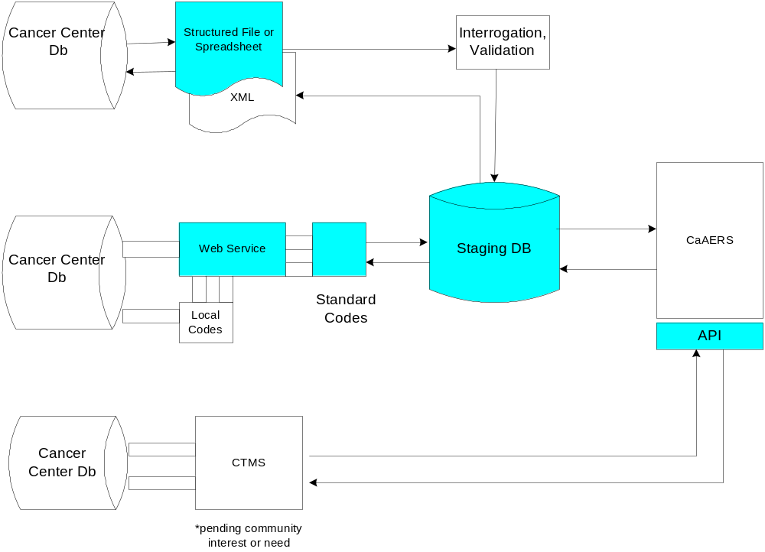

MODULE 2 USE CASES: DATA EXCHANGE WITH LOCAL CTMS DATABASES

2.1 Import of Related Patient and Protocol Data Pre-Existing in a CT Database System

Description
To support existing clinical trials management systems in the environment and reduce duplicate data entry, caAERS ^{sm} will provide the ability to interface to local systems for the abstraction of protocol and study participant data required for the management of adverse events. Three scenarios are presented. The first scenario of this module is based on the use of an XML-based web service and a staging database with import and export facilities for near real-time data transfer. The second scenario supports structured file exchange to a submission queue in caAERS ^{sm} with automated interrogation and validation. The third scenario allows for the provision of published APIs to facilitate data exchange in application modules. A staging database is utilized to increase query performance across the Internet. Standard vocabularies of data elements will be provided.

Actors
caAERS ^{sm} , local clinical trials database management systems, System Administrators (SAs) and domain experts with appropriate role authority.

Pre-Conditions
For the first scenario, a local-developed agent that can send and receive messages has been implemented. For the second scenario, AERS data elements have been mapped to the equivalent data elements in the local systems. For the third scenario, a locally developed application component has been created.

Basic Course-XML-based Web Service
1. The local clinical trial management system and caAERS ^{sm} participate in a platform independent web service-based method for discovering and publishing basic data elements concerning protocol and study participant data required for the management of adverse events. This exchange is near real-time and maybe bidirectional.
2. A staging database is utilized to increase query performance across the Internet.
3. Compliant local services submit XML based documents with consistent structure for consolidation and mapping into standard codes sets (e.g. CDEs) in caAERS ^{sm}

Basic Course-Structure File Set
1. The local clinical trial management system submits a structured file set of protocol and study participant data (e.g. delimited file or spreadsheet) to a submission queue in caAERS ^{sm} where it is interrogated and validated prior to upload in the staging database.
2. File submission may be batched, automatic or user-invoked.

Basic Course-Application Programming Interface
1. The local clinical trial management system and caAERS ^{sm} may implement data exchange capabilities via local developed application programs through a published API from caAERS ^{sm}

Post Conditions
Related protocol and study participant data has been abstracted from a local clinical trials management system and consolidated into caAERS ^{sm} for AE management activities.

Notes
None identified at this time.

Risks
Pending

Use Case dependency
13.0 User login
1.1 Create Protocol Data for AE Abstraction
1.2 Create and Link Study Participant to Protocol

Priority Assignment: TBD
1 – critical to prototype; 2 – future development; 3 – out of grant scope

2.2 Export of AE Information into Local CTMS Databases for Future Aggregation and Analysis

Description
To support existing clinical trials management systems in the environment and reduce duplicate data entry, caAERS ^{sm} will provide the ability to interface to local systems for the exchange of data of study participants on a protocol with AE characteristics. Three scenarios are presented. The first scenario of this module is based on the use of an XML-based web service and a staging database with import and export facilities for near real-time data transfer. The second scenario supports structured file exchange in the form of XML documents. The third scenario allows for the provision of published APIs to facilitate data exchange in locally developed application modules. A staging database is utilized to increase query performance across the Internet. Standard vocabularies of data elements will be provided.

Actors
caAERS ^{sm} , local clinical trials database management systems, System Administrators (SAs) and domain experts with appropriate role authority.

Pre-Conditions
For the first scenario, a local-developed web-service agent that can send and receive messages has been implemented. For the second scenario, local systems must have the capability to receive a consistent structured file format such as XML. For the third scenario, a locally developed application component has been created for exchange of AE information.

Basic Course-XML-based Web Service
1. The local clinical trial management system and caAERS ^{sm} participate in a platform independent web service-based method for discovering and publishing basic data elements concerning data of study participants on protocols with AE characteristics. This exchange is near real-time and maybe bidirectional.
2. A staging database is utilized to increase query performance across the Internet.
3. Compliant local services submit XML based documents with consistent structure for consolidation and mapping into standard codes sets (e.g. CDEs) in caAERS ^{sm}

Basic Course-Structure File Set
1. caAERS ^{sm} exports data in the form of a consistent, structured file format in the form of XML documents.
2. File submission may be batched, scheduled or user-invoked.

Basic Course-Application Programming Interface
1. The local clinical trial management system and caAERS ^{sm} may implement data exchange capabilities via local developed application programs through a published API.

Post Conditions
Related data of study participants on protocols with AE characteristics have been abstracted from caAERS ^{sm} , consolidated and uploaded into the local clinical trial management system for future aggregation and analysis.

Notes
None identified at this time.

Risks
Pending

Use Case dependency
13.0 User login
1.1 Create Protocol Data for AE Abstraction
1.2 Create and Link Study Participant to Protocol
Priority Assignment: TBD
1 – critical to prototype; 2 – future development; 3 – out of grant scope

PACKAGE 3 : MAPPING TO VOCABULARIES AND CODING SYSTEMS
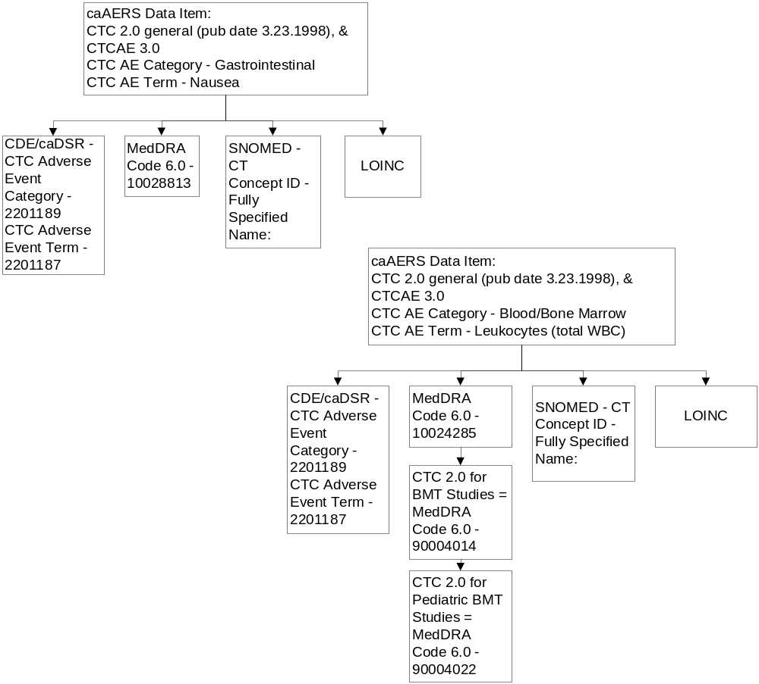

MODULE 3 USE CASES: MAPPING TO VOCABULARIES AND CODING SYSTEMS

3.1 Mapping to Vocabularies and Coding Systems

Description
Existing clinical trials management systems and/or clinical information systems may utilize several standard vocabularies (SNOMED-CT, LOINC, NCI Thesaurus) or coding systems (Codes, CTCAE) and vocabularies (MedDRA) to record clinical information. Standard vocabularies help facilitate electronic exchange of clinical information. Clinical data used in the management of adverse events in caAERS ^{sm} is used for reporting purposes and may require mapping to standard vocabularies (e.g. CDUS). Data elements in caAERS ^{sm} will be provided in these standard vocabularies or coding system for data exchange with an existing CTMS or reporting agency.

Actors
caAERS ^{sm} , local clinical trials database management systems, System Administrators (SAs) and domain experts with appropriate role authority.

Pre-Conditions
The vocabularies/coding systems (SNOMED-CT, LOINC, MedDRA Codes, CTCAE) have been mapped to the caAERS ^{sm} data elements as part of caAERS ^{sm} system configuration.

Basic Course-Forms Creation
1. System Administrator/Domain Expert has accessed the Forms Creator tool of caAERS ^{sm}
2. System Administrator/Domain Expert selects the interested vocabulary for mapping during the creation of a form for collection of specific data items.

Basic Course-Report Generation
1. Domain Expert has accessed the Report Generator tool of caAERS ^{sm}
2. Domain Expert chooses one or more interested vocabularies or coding systems for mapping during the generation of a report.
3. Domain Expert generates interested report.
4. caAERS ^{sm} produces a report with all the data items mapped to the indicated vocabulary/coding system values.

Post Conditions
Data elements in caAERS ^{sm} are provided in selected standard vocabularies or coding systems for data exchange with an existing CTMS or reporting agency.

Notes

- Mappings to vocabularies and coding systems need contribution and validation by the caBIG VCDE SIG.
- caAERS must support ability to select coding system on input and on output. (Note: This requires mapping between CTCAE and MedDRA)
- CTCAE - MedDRA mappings exist but are not perfect. NCI has one that will be our standard. There are many MedDRA terms not covered by CTC.
- Need to support versioning for CTC and MedDRA
- Request: For initial data input capture form, show both codes on input and show mapping. Let users see the mapping and the gaps.
- From Wake Forest and Mayo: 90% of what we report requires CTC. Of MedDRA, typically we only need CTC portion.
- CTC supports “Other” (which has a free text component). Other has a code. But the text portion is not associated with a code.
- The caAERS development team will meet with DCP in a separate meeting to discuss needs of Prevention trials and need for other coding systems.
- UI for input is critical. It can be difficult to find and input codes. This should be prototyped early to allow for early review and revisions. The caAERs development team will investigate using Auto Complete, tool tips, and other approaches to get the UI right here. The caAERS team will also review AdEERS to see how it handles this problem. It may be necessary to create a new use case to address mapping of coding systems.

Risks
1. A change and version control procedure must be defined and implemented to handle updates to vocabularies and coding systems.

Use Case dependency
Use Case 4.1 Forms Creator
Use Case 4.2 Report Generator

Data Item
Data Item | Type | Validation
Vocabulary/Coding System Name | A coded list of vocabularies and coding systems that are mapped and can be applied in caAERS ^{sm} | SNOMED-CT  MedDRA Codes  NCI Thesaurus/CTCAE  LOINC
**See caAERS ^{sm} Use Case Driven Data Dictionary column ‘Mapped Vocabularies/Coding Systems”.
Priority Assignment: TBD
1 – critical to prototype; 2 – future development; 3 – out of grant scope

PACKAGE 4 : REPORT GENERATION AND SUBMISSION TO EXTERNAL AGENCIES
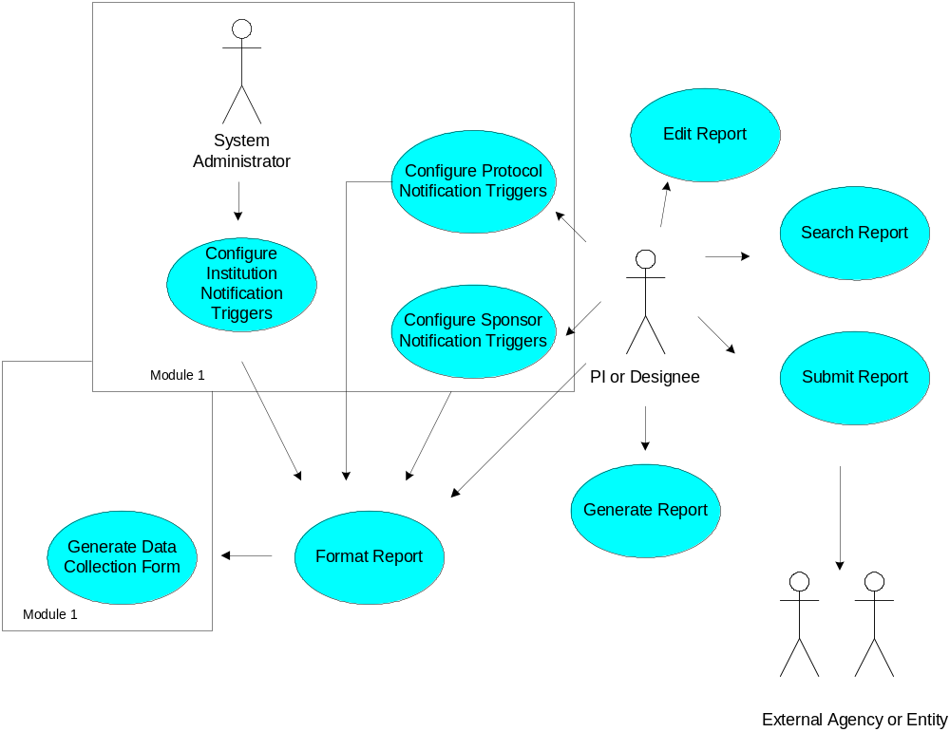

Module 4 Use Cases – Routing to External Agencies

4.1 Create Report Formats

Description
This use case details the creation of data collection forms that will be used to facilitate reporting in caAERS ^{sm} . Templates will be provided for the common regulatory agencies requiring AE reports. Actors may also create data collection forms specific for reporting requirements of other entities.

Actors
PI, domain expert or any other designated user of caAERS ^{sm} with appropriate role authority.

Pre-Conditions
The actor has a user profile and account with an assigned role of appropriate authority. The actor’s workstation is browser-configured according to the policy and procedures of the adopting institution. The actor has logged in and has navigated to the system configuration area of caAERS ^{sm} .

Basic Course
1. User selects Create Report Format tab
2. User searches available external agency report format templates.
3. User selects desired external agency reports and associates their formats with one or more existing protocols
4. User selects Create Formats button. User confirms formats and selected protocol associations.
5. Core data elements common across reporting entities as well as those specific to the target agency of the report as indicated by the executed triggers have been created, associated with the indicated protocol(s) and made available to the forms generator for AE data collection of all AEs
associated with the protols.

Post Conditions
Data collection forms have been created, associated with the indicated protocol(s) and made available to the forms generator.

Alternate Course 4.1.1
1. User selects received notification to Create Report Formats once an AE has been created (Use Case 1.5) and is in the pending state.
2. User logins into to the system, navigates to the system configuration area and selects Create Report Format tab
3. User launches Forms Creator tool and uses its wizard to place available data collection items on to a form.
4. User associates data collection form with one or protocols. User selects option to associate form with all AEs for the associated protocol(s).
5. User selects Create Formats button. User confirms formats and selected protocol associations.
5. Core data elements common across reporting entities as well as those specific to the target agency of the report as indicated by the executed triggers have been created, associated with the indicated protocol(s) and made available to the forms generator.

Data Item
Data Item | Type | Validation
 | TBD | TBD
 | TBD | TBD
 | TBD | TBD

Notes
Pending analysis above with contributors.

Risks
None identified at this time.

Use Case Dependency
1.1Create Protocol Data for AE Abstraction
1.8 Create Institution Notification Triggers
1.9 Create Sponsor Notification Triggers
1.10 Create Protocol Notification Triggers
1.5 Create AE

Priority Assignment
TBD

1 – critical to prototype; 2 – future development; 3 – out of grant scope

4.2 Generate Report Form

Description
This use case details the generation of a dynamic report form. The form is generated based on report formats indicated by the triggers and/or selected by the user.

Actors
Protocol staff members with appropriate role authority.

Pre-Conditions
The system administrator has entered all appropriate values for institution level notification triggers. Protocol and sponsor triggers (if applicable) have been defined. The Study Participant for which the AE is created exists in caAERS ^{sm} and is linked to an existing protocol in caAERS ^{sm.} An AE has successfully been created. Notification trigger have executed. Data collection forms (report formats) have been previously created and stored.

Basic Course
1. A dynamic form is presented for subsequent AE data collection (Use Case 1.6). The form contains core data elements common across reporting entities as well as those specific to the target agencies of the report(s) as indicated by the executed triggers and/or user selection of report formats.
2. The form has been pre-populated with AE data previously entered on its creation.
3. The “requiredness” of each data element for the target report(s) has been identified.

Post Conditions
A report form has been generated for subsequent data collection on an AE. Data fields for the report form have been pre-populated with previously entered data on the AE. Core data elements and their “requiredness” are available on the form. Report format are collated and made available based on reporting requirements of the notification triggers and/or those defined by the user.

Alternate Course 4.2.1
1. The actor is notified to generate a report form as indicated by executed triggers.
2. The actor selects which report formats to generate. The actor may confirm and/or edit those indicated by the executed triggers.
3. A dynamic form is presented for subsequent AE data collection (Use Case 1.6). The form contains data elements of report formats selected and confirmed for use by the actor. The “requiredness” of each data element is available on the form.

Data Item
Data Item | Type | Validation
 | TBD | TBD
 | TBD | TBD
 | TBD | TBD

Notes
Pending analysis above with contributors.

Risks
None identified at this time.

Use Case Dependency
1.1Create Protocol Data for AE Abstraction
  - Create AE
4.1 Create Report Formats
1.8 Create Institution Notification Triggers
1.9 Create Sponsor Notification Triggers
1.10 Create Protocol Notification Triggers
4.1 Create Report Formats

Priority Assignment TBD
1 – critical to prototype; 2 – future development; 3 – out of grant scope

4.3 Submit Report

Description
This use case details the submission of a created SAE/AE report to an external agency or other entity. The report can cover multiple SAE/AE, but only one can be grade 5 and in a multiple submission one SAE/AE should be marked as primary if possible. PDF and XML should both be supported as output options. Once a report is submitted it can not be withdrawn, only amended.

Actors
The PI or any other designated user of caAERS ^{sm} with appropriate role authority.

Pre-Conditions
The Study Participant for which the AE is created exists in caAERS ^{sm} and is linked to an existing protocol in caAERS ^{sm.} The actor has successfully logged into the system and created the AE. Report formats have been created and are utilized on the data collection form. The actor has completed data collection on the AE. The AE is in the completed state.

Basic Course
1. At the time of completion of the AE data collection form, the actor is prompted to create the report in PDF format.
2. Upon successful generation of the PDF file, the actor is prompted to verify email address for electronic submission of the file.
3. The actor is prompted to confirm submission of the file.
4. Upon successful submission of the PDF file, an electronic receipt with a timestamp of the transaction and status has been created and is available to the actor. It is also stored and accessible in the system.
5. A ticket number or other unique identifer from the receiving agency of the report, if applicable, is also made available to the actor and is stored and accessible in the system.
6. If submission of the file is unsuccessful, notification to the actor is given, and this status is stored and accessible in the system.

Post Conditions
A report for an AE/SAE has been electronically validated and submitted to the interested external agency or entity. An electronic receipt with a timestamp of the transaction has been created and is available to the actor and stored and accessible in the system. A ticket number from the receiving agency, if applicable, is also made available to the actor and stored and accessible in the system.

Alternate Course 4.3.1
1. At the time of completion of the AE data collection form, the actor is prompted to confirm encrypted electronic transfer of the report data if such a transfer is available in the system for the target agency or entity.
2. Upon successful transmission of the data, an electronic receipt with a timestamp of the transaction and status is created and made available to the actor. It is also stored and accessible in the system.
3. A ticket number from the receiving agency, if applicable, is also made available to the actor and is stored and accessible in the system.
3. If transmission is unsuccessful, notification to the actor is given, and this status is stored and accessible in the system.

Data Item
Data Item | Type | Validation
 | TBD | TBD
 | TBD | TBD
 | TBD | TBD

Notes
- Can AdEERS accept a PDF format? The answer was not known. But thought unlikely.
- Is AdEERS planning to accept electronic report submissions? This needs to be investigated.
- Should caAERS support HL7 format? Needs further investigation. But thought unlikely in near term.
- caAERS needs to support handling of updated and modified reports (i.e., amendments). This also implies receipt of initial confirmation and ticket # from AdEEERS.
- Do we need to capture 'reason for change' info from user when updating modifying reports (for 21 CRF 11 compliance)? Further investigation needed.
- David reported, based on input from AdEERS users, that ticket # stays the same for a report even after it is amended. Instead, the amendment number changes. I.e., Ticket # 1, Amendment 1…. Ticket # 1, Amendment 2.
- In general, it was agreed that the report use cases need further analysis and review and fleshing out. We need to investigate AdEERS business rules and make sure this intelligence is adequately reflected in caAERS system/ report generation feature set.
- Remember that the CRA knows the reportability of an AE best and ultimate control should lie with him or her (i.e., allow rule overrides).

Risks
None identified at this time.

Use Case Dependency
1.1Create Protocol Data for AE Abstraction
1.8 Create Institution Notification Triggers
1.9 Create Sponsor Notification Triggers
1.10 Create Protocol Notification Triggers
4.1 Format Report
4.2 Create Report Form

Priority Assignment
TBD

1 – critical to prototype; 2 – future development; 3 – out of grant scope

13.0 General Use Cases

13.1 Login

Description
The actor logs into caAERS ^{sm}.

Actors
The PI or any other designated user of caAERS ^{sm}.

Pre-Conditions
The actor has a user profile and account with an assigned role and issued a user name and temporary password by the System Administrator (see System Administration use case package). The actor’s workstation is browser-configured according to the policy and procedures of the adopting institution. The actor has navigated to caAERS ^{sm} website

Basic Course
1. caAERS ^{sm} displays a page, which prompts the actor to supply a Domain, User ID and Password.
2. The actor selects the Domain from a pick list.
3. The actor enters the User ID and Password and submits it to caAERS ^{sm.}
4. caAERS ^{sm} verifies the Domain-User ID-Password combination exists and is still current.

Post Conditions
The actor is logged into caAERS ^{sm} as indicated by display of his/her User ID on the homepage of the application.

Alternate Course
13.11 Change Password
1. For a first time login or an expired password, caAERS ^{sm} displays a "Change Password" option.
2. On selection of this option, the actor inputs his/her old password and new password according to the institution’s validation rules
3. caAERS ^{sm} validates the new password and indicates this to the user.

13.12 Login Failure
1. caAERS ^{sm} does not recognize the Domain-User ID-Password combination.
2. caAERS ^{sm} will display an error message and an option for the user to return to the login screen to try again.
3. caAERS ^{sm} will lock the account after a configurable number of failed login attempts.

Data Item

Data Item | Type | Validation
Domain | TBD | TBD
UserID | TBD | TBD
Password | TBD | TBD

Notes
On the first attempt, the user is directed to change the initially assigned password and cannot proceed without performing this task.

Risks
TBD

Use Case Dependency
Create User Profile (Pending SA Use Case)

Priority Assignment
TBD
1 – critical to prototype; 2 – future development; 3 – out of grant scope

13.2 Change Password

Description
The actor changes his/her password or is prompted by caAERS ^{sm} to change his/her password.

Actors
The PI or any other designated user of caAERS ^{sm}.

Pre-Conditions
The actor has a user profile and account with an assigned role and issued a user name and temporary password by the System Administrator (see System Administration use case package) or has a current password. The actor’s workstation is browser-configured according to the policy and procedures of the adopting institution. The actor has navigated to caAERS ^{sm} website.

Basic Course
1. The actors selects or is prompted to select a “Change Password” option.
2. The actor enters the following required fields:
old password
new password
new password confirmation
3. caAERS ^{sm} verifies the current password.
4. caAERS ^{sm} validates the new password against the duplicate and system rules.
5. caAERS ^{sm} updates the password for the user account
6. caAERS ^{sm} informs the actor that the password change has taken effect.

Post Conditions
The actor has changed his/her password.

Alternate Course

13.21 The current password is incorrect – inform the actor of the error and prompt for correction.
13.22 New password does not match the confirmation password – inform the actor of the error and prompt for correction.
13.23 The password is not within configurable parameters- inform the actor of the error and prompt for correction.

Data Item
Data Item | Type | Validation
Current Password | TBD | TBD
New Password | TBD | TBD
Confirmation Password | TBD | TBD

Notes
None identified at this time.

Risks
None identified at this time.

Use Case Dependency
Create User Profile (Pending SA Use Case)

Priority Assignment
TBD
1 – critical to prototype; 2 – future development; 3 – out of grant scope

Potential Use Cases

Add New Version of Existing Protocol

Create Report Template (needed for customized reports in use case 4.1)

